## DOCKE­­­­­­R PROJECT : IIEC RISE TRAINING APRIL 2020

## BY: BHANVI MENGHANI

**DOCKER INTO OWNCLOUD**

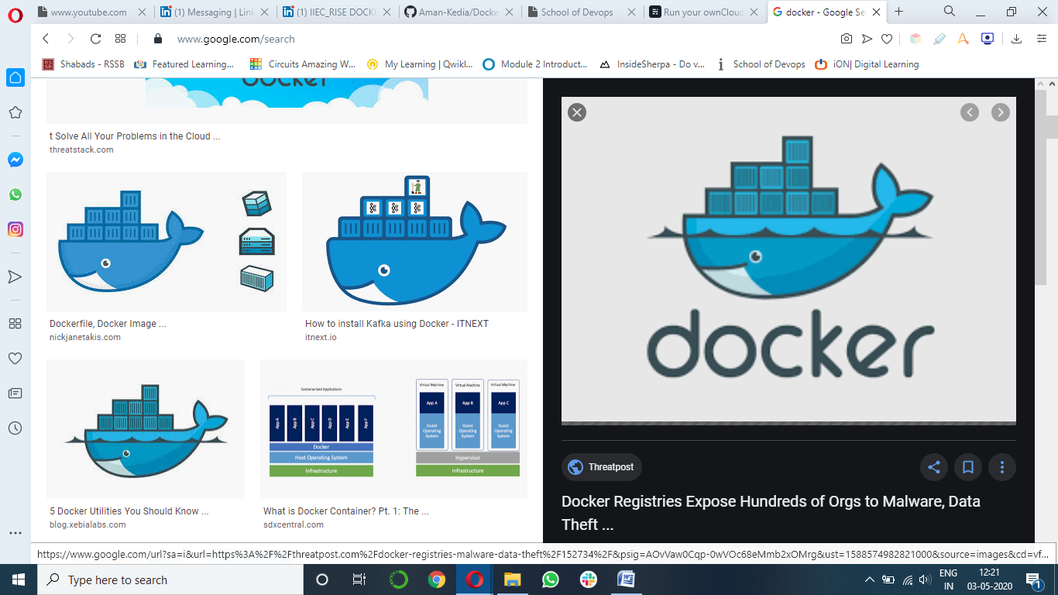 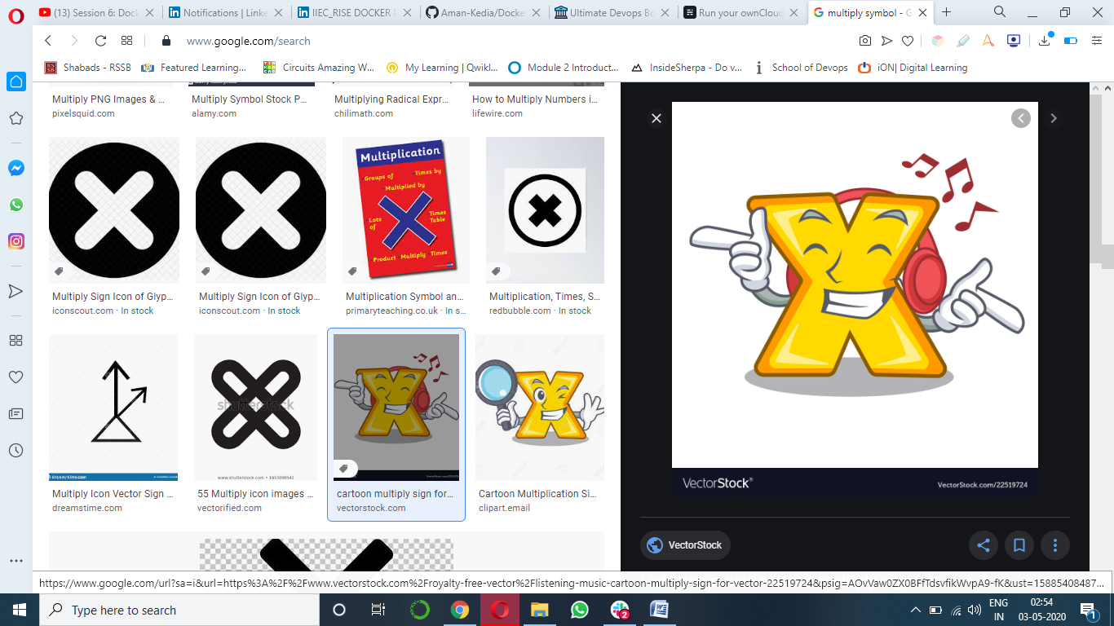 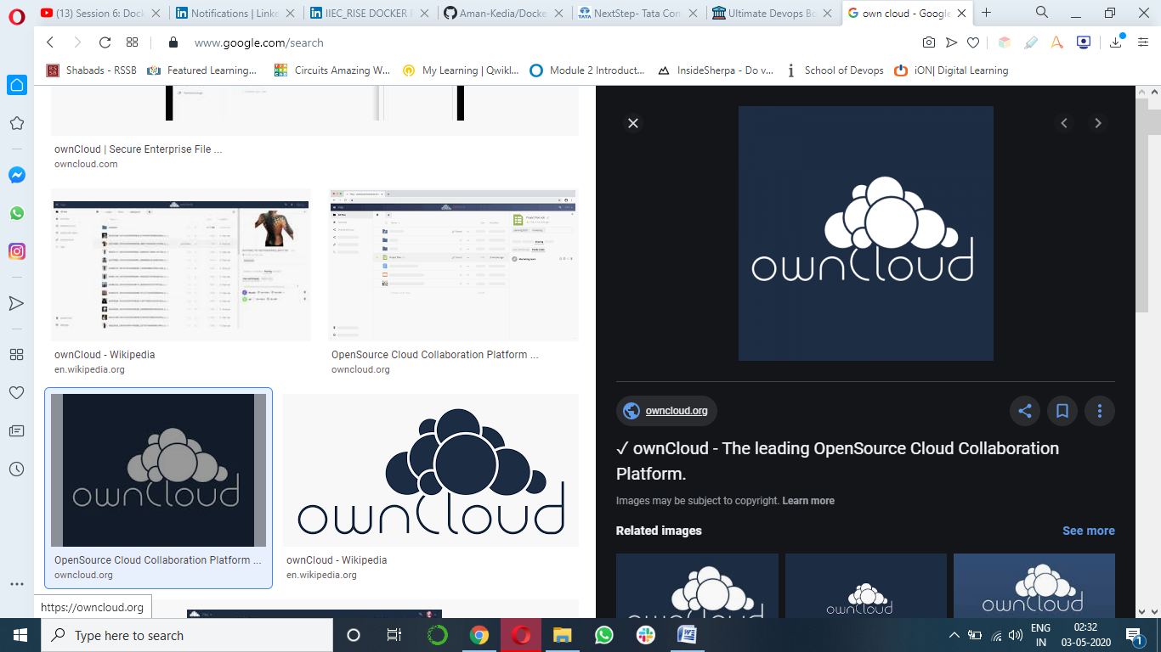

## Tired of file sharing/sync/cloud services like iCloud and Dropbox? Maybe you want to have more control over your own assets. Why don't you run your own service using ownCloud?

## This brief demo will guide you how to run your ownCloud on any server with Containers

## Lets first grab some basics. About what is docker and own cloud

## Docker

## Docker Inc. was founded by Solomon Hykes and Sebastien Pahl .Docker is a set of platform as a service products that uses OS-level virtualization to deliver software in packages called containers. Containers are isolated from one another and bundle their own software, libraries and configuration files; they can communicate with each other through well-defined channels.

## Own cloud

## ownCloud is a self-hosted file sync and share server. It provides access to your data through a web interface, sync clients or WebDAV while providing a platform to view, sync and share across devices easily — all under your control.

## ownCloud’s open architecture is extensible via a simple but powerful API for applications and plugins and it works with any storage.

## Set up for project

Following is the description of the set up I used for building the project:

1. Oracal Virtual Box
2. RedHat Linux RHEL8
3. Docker
4. Mysql
5. Owncloud

### Side note: use Bridge Adapter in Networks if Running on Virtual Machine

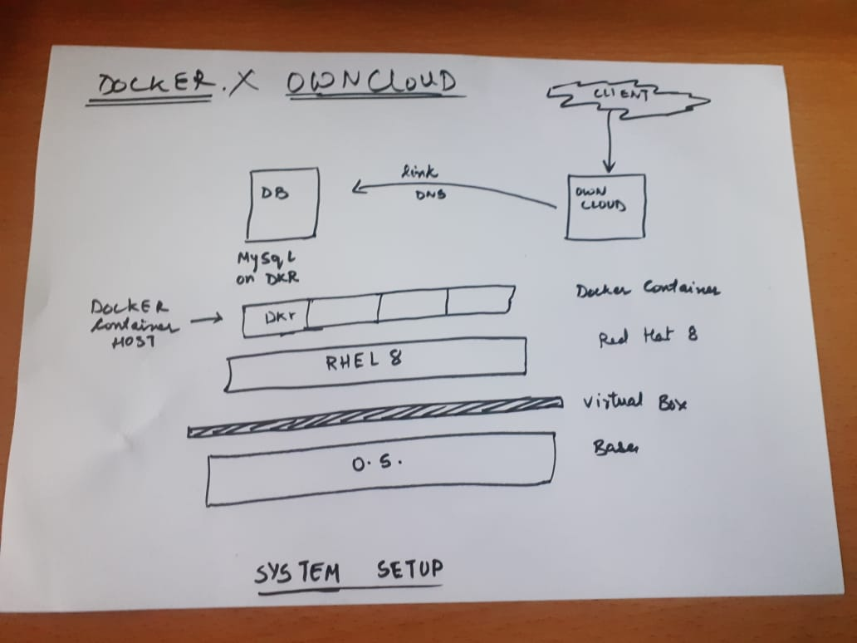

**Pre requistics / installation**

1. Installing red hat : refer to the IIEC rise you tube vedios by vimal sir: <https://www.youtube.com/watch?v=8Q83qs2MAVA&list=PLAi9X1uG6jZ2b1mUmrUcc_aEoc8tfss8e&index=3>
2. Installing docker : refer to the IIEC rise you tube vedios by vimal sir:

<https://www.youtube.com/watch?v=NPgXHA41-YM&t=7617s>

1. Yum configuration commands : <https://www.youtube.com/watch?v=DPyohwkqvHo&list=PLAi9X1uG6jZ2b1mUmrUcc_aEoc8tfss8e&index=15>
2. Setting docker compose:

<https://www.youtube.com/watch?v=3Kn6_b-1mK4&list=PLAi9X1uG6jZ30QGz7FZ55A27jPeY8EwkE>

**Environment setup commands:**

The following table explains the basic commands to make sure that we do not make any silly errors

|  |  |  |
| --- | --- | --- |
| SR NO. | REQUIRMENT | COMMAND |
| 1. | To prevent any firewall intereptions | systemctl stop firewalld |
| 2. | To connect to web server | systemctl start httpd |
| 3. | To start the docker servvices | systemctl start docker |
| 4. | To remove any previous containers | Docker rm <cont. id> |

**Project assembly :**

Once the environment of redhat 8 and docker and mysql is set up we can start with our project oriented development:

1. Make a directory in your root folder , go into that directory

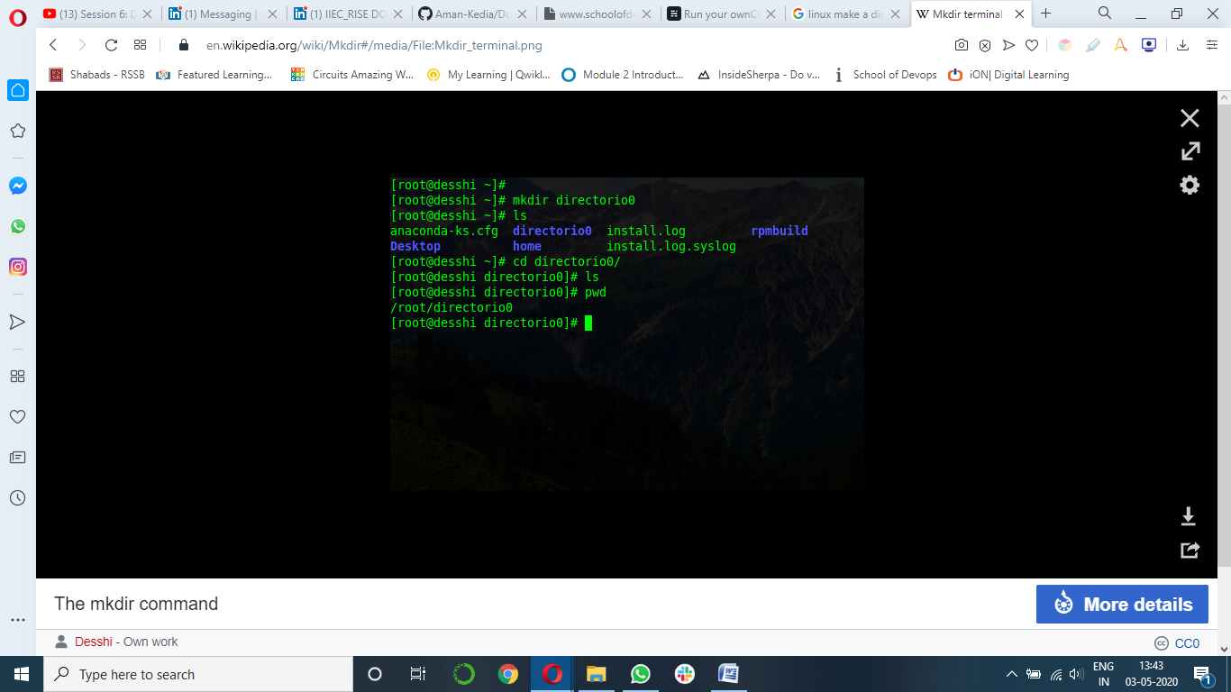

1. Form a file with the name < docker-compose.yml > in that dir

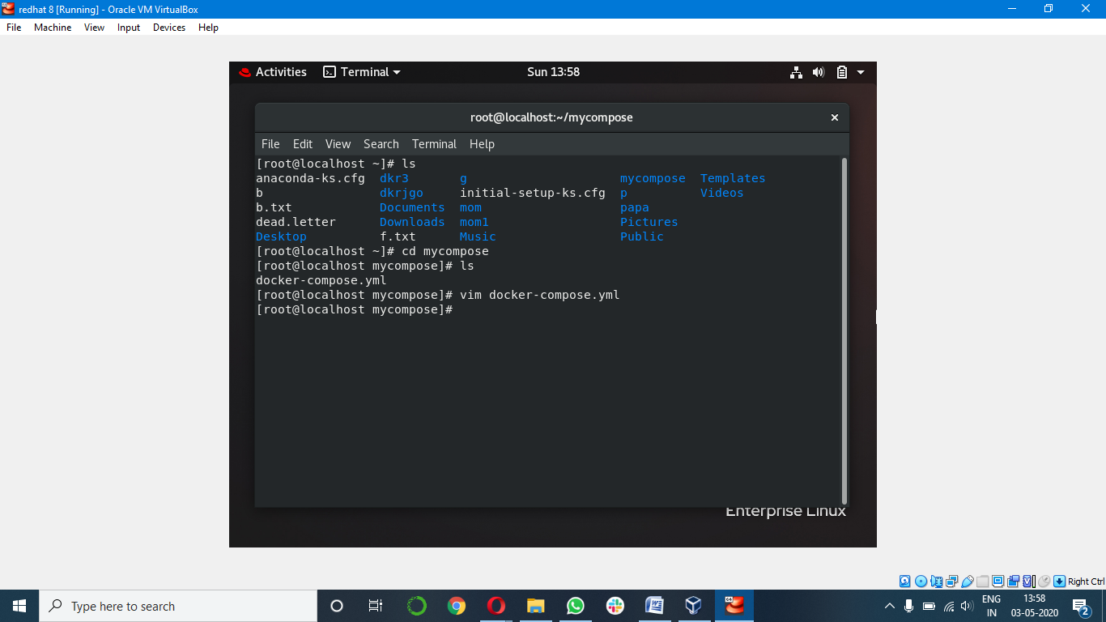

3. copy the code written in the file “docker-compose.yml”provided in the repo .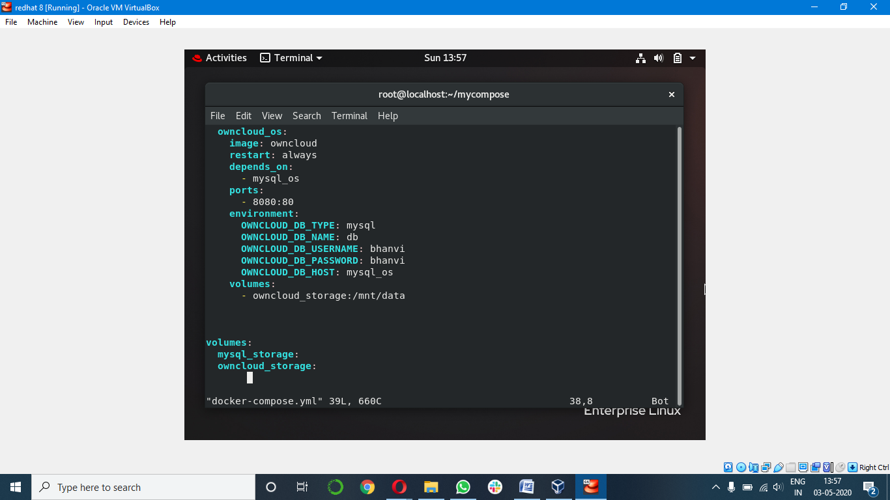

4.Run < docker-compose up > command and here we go

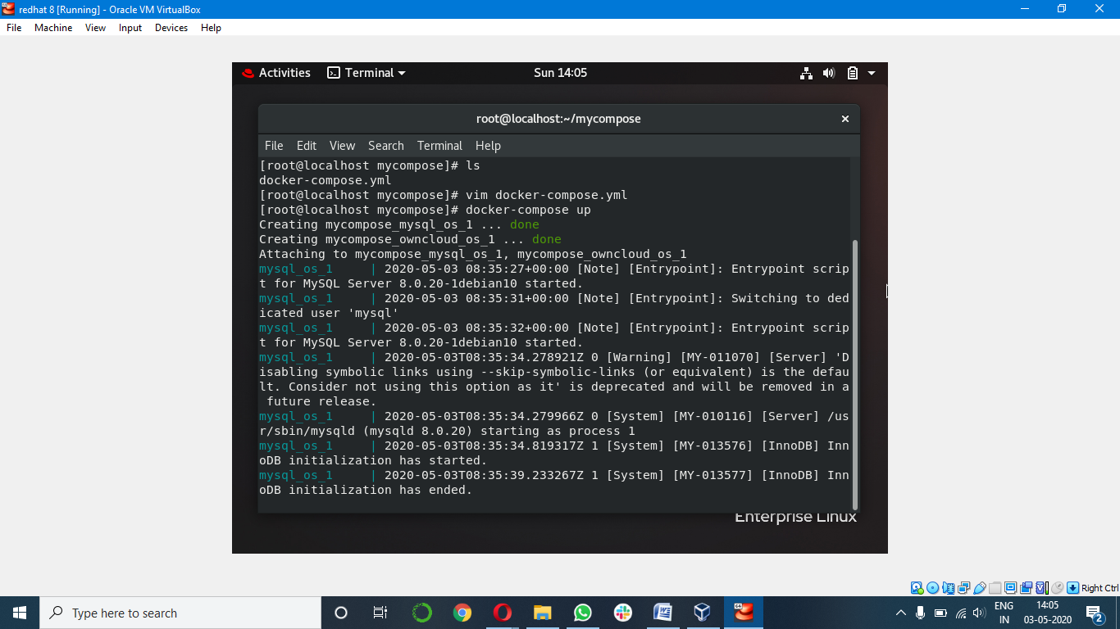

1. Now in you browser run <<container ip>:8080 > to see your page

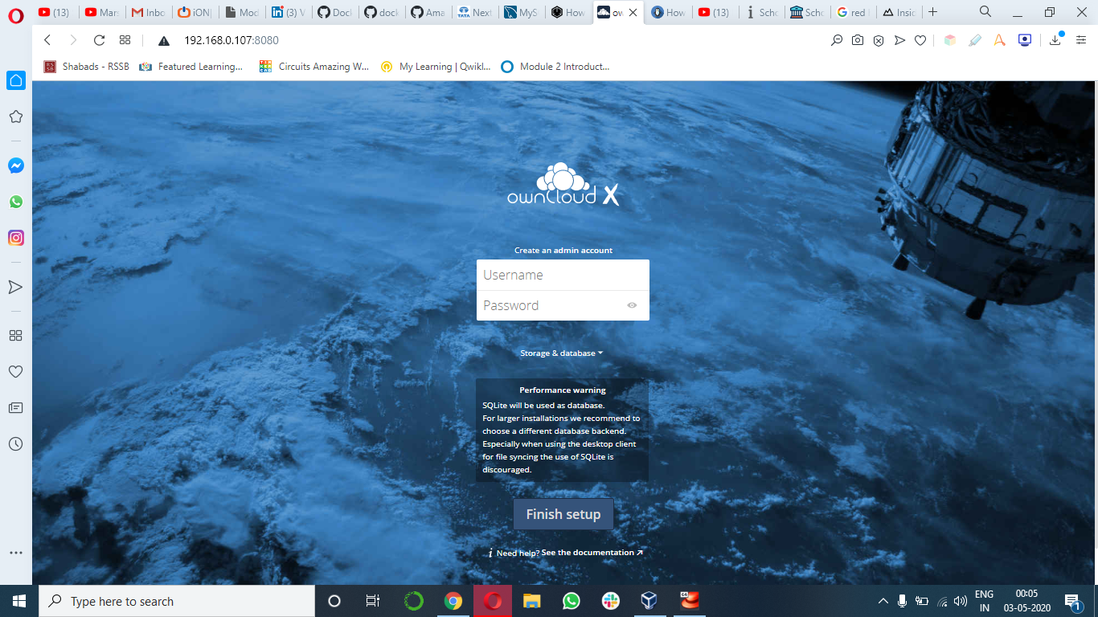

Ip address with port no:

1. Acces the page through username and password

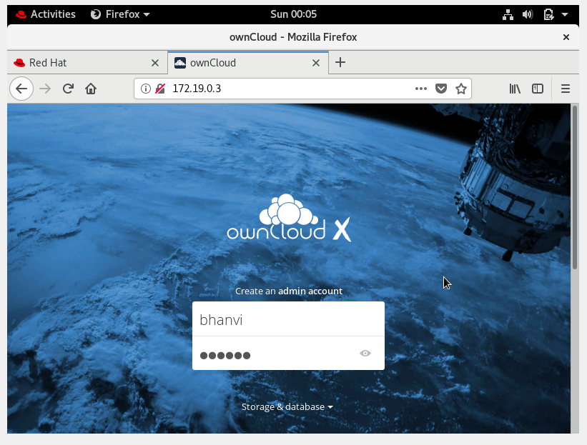

1. Hurray now you can start synchronizing and sharing your files!

The stepwise process can be seen in the snapshorts folder also.

